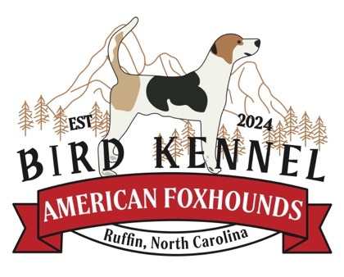
FOXHOUND ADOPTION AGREEMENT
(BIRD KENNELS, REVISED 2/4/2025)

CURRENT OWNERS NAME: BIRD KENNEL (ANDREW BIRD)
PHONE NUMBER: (336)609-1515
CURRENT ADDRESS: 231 LINDSEYS DRIVE, RUFFIN NC 27326

FOXHOUND DESCRIPTION:

NAME: ______________________________________LITTER NUMBER: _______________________

SEX: (MALE / FEMALE) COLOR: ______________________________________________________

WHELPING DATE: ____________________________________________ UNALTERED: (YES / NO)

I, ____________________________________________________________________________________, hereafter referred to as the adopter, hereby agree that the above described animal is being adopted by me solely as a pet for myself and/or my immediate family. I agree that I will not sell, give away or otherwise dispose of said animal to any person(s), dealer, retailer, auction, institute or any other entity for any reason. If at a later date I am unable or unwilling to keep this pet, I agree to first contact the above described current owner and give them the option to reclaim said pet at no charge.
I hereby agree to care for the above described pet in a humane and responsible manner and to provide it with clean and adequate shelter, food, water and veterinary care. I further agree that said pet shall reside inside my home or in a designated shelter outside my home.
I hereby understand and agree that the current owner makes no representations or warranties, expressed or implied, about the above mentioned animal's temperament and is hereby absolved from any liability for future damages or injuries caused by said animal. I also understand and agree that the current owner further gives no guarantees, expressed or implied, of the suitability of the animal to the adopter and/or his family.
ADPOTERS NAME: _____________________________ PHONE NUMBER: ____________________
ADOPTERS ADDRESS: _______________________________________________________________
I certify that all statements made by me on this adoption agreement are true and correct. I agree that the current owner has the right to confiscate the above described animal in the event that any statements made by me are found to be false.

ADOPTERS SIGNATURE: __________________________________ DATE: ____________________
WITNESS SIGNATURE: ____________________________________ DATE: ____________________

